User Story
A user story is the smallest unit of work in an agile framework. It’s an end goal, not a feature, expressed from the software user’s perspective.
A user story is an informal, general explanation of a software feature written from the perspective of the end user or customer.
The purpose of a user story is to articulate how a piece of work will deliver a particular value back to the customer. Note that "customers" don't have to be external end users in the traditional sense, they can also be internal customers or colleagues within your organization who depend on your team
Stories fit neatly into agile frameworks like scrum and kanban. In scrum, user stories are added to sprints and “burned down” over the duration of the sprint. Kanban teams pull user stories into their backlog and run them through their workflow. It’s this work on user stories that help scrum teams get better at estimation and sprint planning, leading to more accurate forecasting and greater agility. Thanks to stories, kanban teams learn how to manage work-in-progress (WIP) and can further refine their workflows.
User stories are also the building blocks of larger agile frameworks like epics and initiatives. Epics are large work items broken down into a set of stories, and multiple epics comprise an initiative. These larger structures ensure that the day-to-day work of the development team (on stores) contributes to the organizational goals built into epics and initiatives.
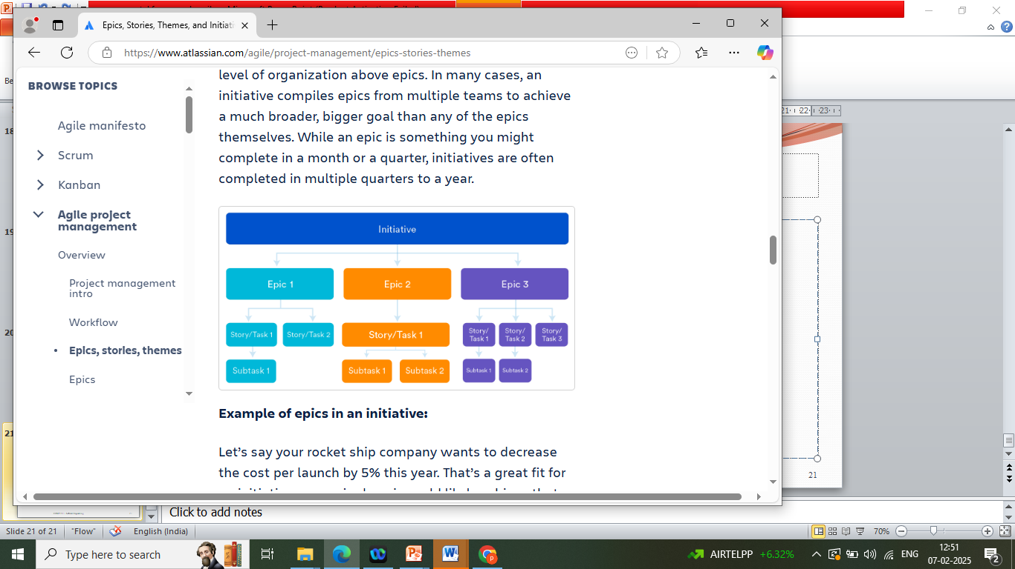

Why create user stories?
For development teams new to agile, user stories sometimes seem like an added step. Why not just break the big project (the epic) into a series of steps and get on with it? But stories give the team important context and associate tasks with the value those tasks bring.

User stories serve a number of key benefits:
• Stories keep the focus on the user. A to-do list keeps the team focused on tasks that need to be checked off, but a collection of stories keeps the team focused on solving problems for real users
. • Stories enable collaboration. With the end goal defined, the team can work together to decide how best to serve the user and meet that goal.
• Stories drive creative solutions. Stories encourage the team to think critically and creatively about how to best solve for an end goal.
• Stories create momentum. With each passing story, the development team enjoys a small challenge and a small win, driving momentum.
Working with user stories
Once a story has been written, it’s time to integrate it into your workflow. Generally a story is written by the product owner, product manager, or program manager and submitted for review.
During a sprint or iteration planning meeting, the team decides what stories they’ll tackle that sprint. Teams now discuss the requirements and functionality that each user story requires. This is an opportunity to get technical and creative in the team’s implementation of the story. Once agreed upon, these requirements are added to the story.
Another common step in this meeting is to score the stories based on their complexity or time to completion. Teams use t-shirt sizes, the Fibonacci sequence, or planning poker to make proper estimations. A story should be sized to complete in one sprint, so as the team specs each story, they make sure to break up stories that will go over that completion horizon.
Consider the following when writing user stories:
• Definition of “done” — The story is generally “done” when the user can complete the outlined task, but make sure to define what that is.
• Outline subtasks or tasks — Decide which specific steps need to be completed and who is responsible for each of them.
• User personas — For whom? If there are multiple end users, consider making multiple stories. • Ordered Steps — Write a story for each step in a larger process.
• Listen to feedback — Talk to your users and capture the problem or need in their words. No need to guess at stories when you can source them from your customers.
- Ordered Steps — Write a story for each step in a larger process
• Time — Time is a touchy subject. Many development teams avoid discussions of time altogether, relying instead on their estimation frameworks. Since stories should be completable in one sprint, stories that might take weeks or months to complete should be broken up into smaller stories or should be considered their own epic.

Product Backlog
What is a product backlog?
A product backlog is a prioritized list of tasks — including new features to build, bugs to fix, improvements to implement, etc. — that is derived from the product requirements and roadmap. It is a scrum artifact that serves as a to-do list for agile development teams.
Let’s define product backlog even more granularly. According to the Scrum Guide, a product backlog is “an emergent, ordered list of what is needed to improve the product. It is the single source of work undertaken by the Scrum Team.”

Breaking down this definition piece by piece:
o Emergent — The product backlog is not a plan; it evolves as you learn. If you’re not removing old items, you’re either not learning or getting stuck with the past and blocking the future
o Improve the product — A backlog is neither a wishlist, nor a set of requirements, nor promises. It contains items that contribute to value for users and businesses
o Single source of work — You should have only a single product backlog. Having separate tech, discovery, and idea backlogs is a common mistake. Doing so creates silos and stymies collaboration
Here’s the bottom line: the simpler your product backlog, the better.
What does a product backlog include?
When considering what to include in a product backlog, the key is to focus on collaboration instead of prescriptive items.
The following items are commonly included in a product backlog:
o Epics
o User stories
o Bugs
o Tasks
o Spikes
Epics :
An epic represents a big picture of something you want to achieve. It should name the desired result and why that matters. An example of an epic might be implementing search recommendations with the expected outcome of increasing conversion rate.
User stories: A user story names the problems you want to solve and why they matter. User stories should be enablers to reaching the goal of epics. But keep in mind that the focus is on collaboration and not contracts. Keep your stories as invitations for conversations and refine them with your teams.
Bugs :A bug is an unexpected behavior. When creating bugs, you should precisely name how to reproduce them and estimate the importance and percentage of impacted users.
Tasks: The team doesn’t work only on features. They also have some jobs to keep the lights on.
Spikes :Sometimes, the team doesn’t know where to start. They may have understood the problem but solving that requires some research.
Who is accountable for prioritizing the product backlog?
The content of a product backlog must be aligned with your product strategy, which hopefully aligns with your product vision.
The items inside of your product backlog enable your team to get a step closer to the goals you’re pursuing. If not, they should be removed.
Roles involved in product backlog management include the product manager, stakeholders, and agile teams. Let’s take a closer look at the responsibilities of each.
Product manager
The product manager is ultimately responsible for the product backlog’s content and prioritization. However, that doesn’t mean that PMs must work alone. Great professionals set the right context and let the team evolve the product backlog content.
Stakeholders
Many teams encourage stakeholders to create tickets in the product backlog. That often gets in the way of collaboration because it becomes a service-provider relationship.
Agile teams :
Team members are encouraged to create product backlog items. For example, software engineers commonly create tech debt items and designers point out usability glitches. That said, it’s the product manager’s responsibility to decide what makes it to the top of the list. The secret is to inform the why behind each item and what that enables.

Below are some best practices for effective backlog management:
o Be goal-oriented
o Keep it simple
o Don’t keep dinosaurs
o Ditch definitions of ready
Be goal-oriented :
All items inside the product backlog must be related to an ultimate goal. If backlog items don’t level up to an established goal, you should remove them.
Keep it simple:
Keep your backlog items focused on opportunities and problems. Don’t write detailed requirements.
Don’t keep dinosaurs : The older a backlog item is, the less relevant it becomes. The quicker you remove outdated items, the faster you can focus on your learnings.
Ditch definitions of ready :Some teams like having standards for product backlog items. This can hurt your collaboration.
Backlog management antipatterns to avoid.
There are many common antipatterns associated with product backlog management. We’ve already touched on some of them, but here is a more complete list of traits your product backlog should NOT have:
o Wishlist
o Multiple product backlog
o Extensive requirements
o No space for learning
o Strict format

